3.1 Defining the Derivative Worksheet

- Find if .

- Consider the function .
- Find an equation that will tell you slope of any tangent line on the graph of .

- Construct the equation of a line that is tangent to at the point where .

- Find the derivative of .

- Find an equation of the tangent line to the curve at the given point.
- ,

- ,

- ,

- ,

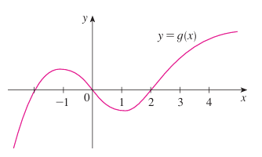
- For the function whose graph is shown below, arrange the following numbers in increasing order.

- The displacement (in meters) of a particle moving in a straight line is given by the equation , where t is measured in seconds. Find the velocity of the particle at times:

- The displacement (in meters) of a particle moving in a straight line is given by , where t is measured in seconds.
- Find the average velocity of the particle over each time interval:

- Find the instantaneous velocity when .

- Sketch a picture of the function s and draw the secant lines whose slopes are the average velocities in part (a) and the tangent line whose slope is the instantaneous velocity in part (b).

- A warm can of soda is placed in a cold refrigerator. Sketch the graph of the temperature of the soda as a function of time. Is the initial rate of change of the temperature greater or less than the rate of change after an hour?

- The cost of producing x ounces of gold from a new gold mine is dollars.
- What is the meaning of the derivative ? What are its units?

- What does the statement mean?

- The number of bacteria after t hours in a controlled laboratory experiment is .
- What is the meaning of the derivative ? What are its units?

- Suppose there is an unlimited amount of space and nutrients for the bacteria. Which do you think is larger, or ? If the supply of nutrients is limited, would that affect your conclusion? Explain.

- Each of the following limits represents the derivative of some function f at some number a. State the function f and value of a in each case.

